**OOSE Lab Terminal Project**

**Gym Management system**



**Submitted to:**

**Mam Hafiza Sundus**

**Submitted by:**

**Name: Raja Farhan Muazzam**

**Reg no: SP21-BSE-071 (BSE-4B)**

**Name: Omer Abdul Rauf**

**Reg no: SP21-BSE-069 (BSE-4B)**

INTRODUCTION

**PROBLEM STATEMENT:**

For Human health, it is very necessary to keep yourself and your mind healthy. For this purpose, it will very necessary to exercise. There are many gyms where people can go and do physical exercise. More and more people are enrolling in gym with the growing trend of people keeping themselves fit. It will be very difficult to keep the records and save them as well and also keeping record of the payments detail. So, we need a software that will keep the record of client and will be permanently stored.

**PROBLEM SOLUTION:**

We are developing a software, a management system to solve this problem to allow the administration of gyms to keep the record of customers in large numbers. This software is capable enough to keep the record of clients and payments as well in just one click.  This software is interactive, describable and have user friendly interface environment where one can register and work comfortably and easily.

**SCOPE:**

Our project will have the following features which will be developed in our project. Some of the features are as:

Our system will have user friendly and trendy interface.

Administration is designed to manage the information of trainer and trainee as well.

It will keep the track of each customer’s personal details individually.

Upon entering a new customer, system will automatically calculate the monthly fee of the customer according to training equipment.

Will keep the record of salary of the employee and fees of the customer.

It will allow the administration to view, search, save and delete the customer’s and employee’s information.

The system will keep the record of equipment available in the gym.

Our system will assign trainer automatically according to requirement and price client can carry.

**EXPECTED DELIEVERABLE:**

  • System analysis documentation

• System design documentation

• System implementation documentation

**FUNCTIONAL REQUIREMENTS:**

REGISTRATION

SIGN IN

TIME SCEHEDULING

DIET PLANNING

WORKOUT PLANNING

MANAGE ACCOUNT

PAYMENT MANAGEMENT

SIGN OUT

**NON_FUNCTIONAL REQUIREMENTS:**

USABILITY

PERFORMANCE

MAINTANANCE

SECURITY

UPGRADATION

Reliable

Efficient

**WORK BREAKDOWN STRUCTURE**

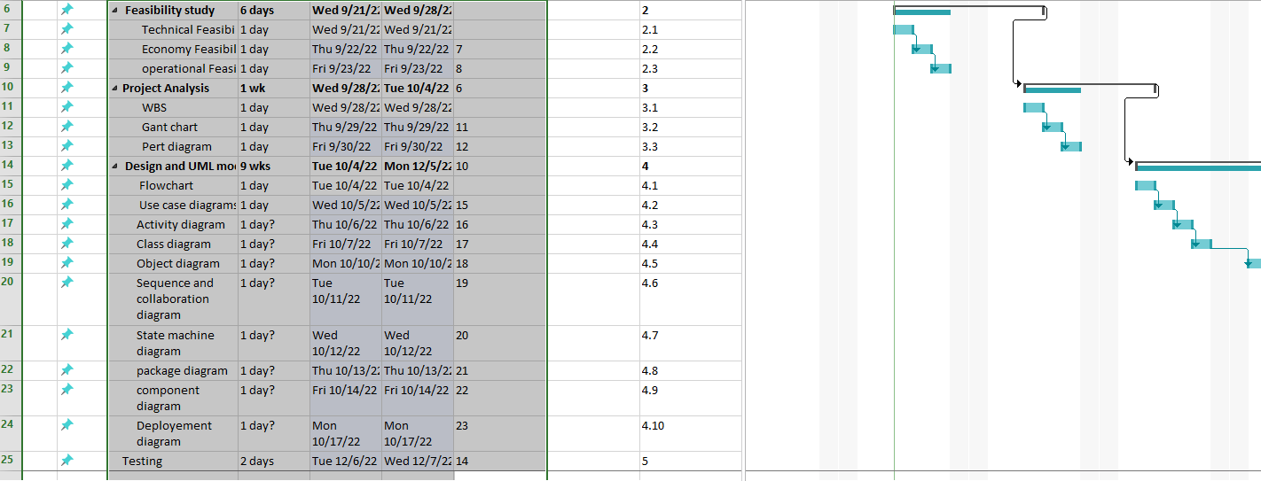

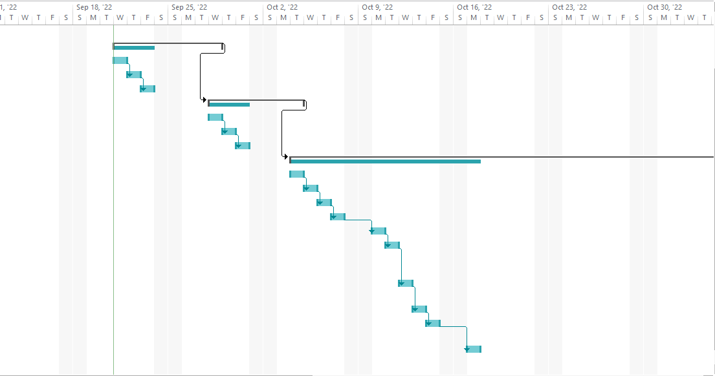

**USE CASE:**

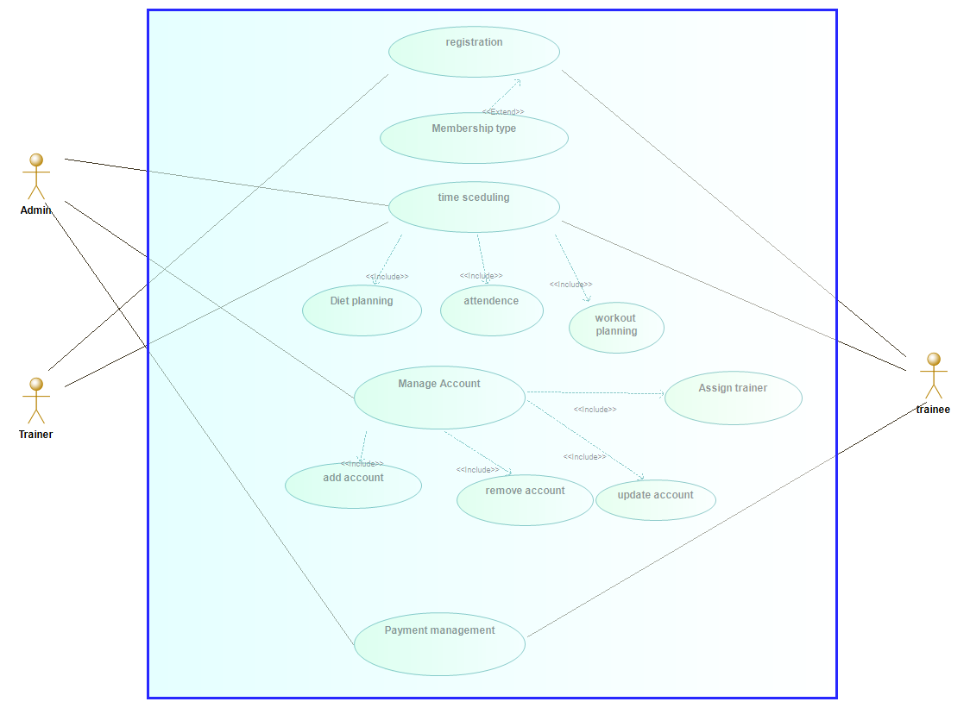

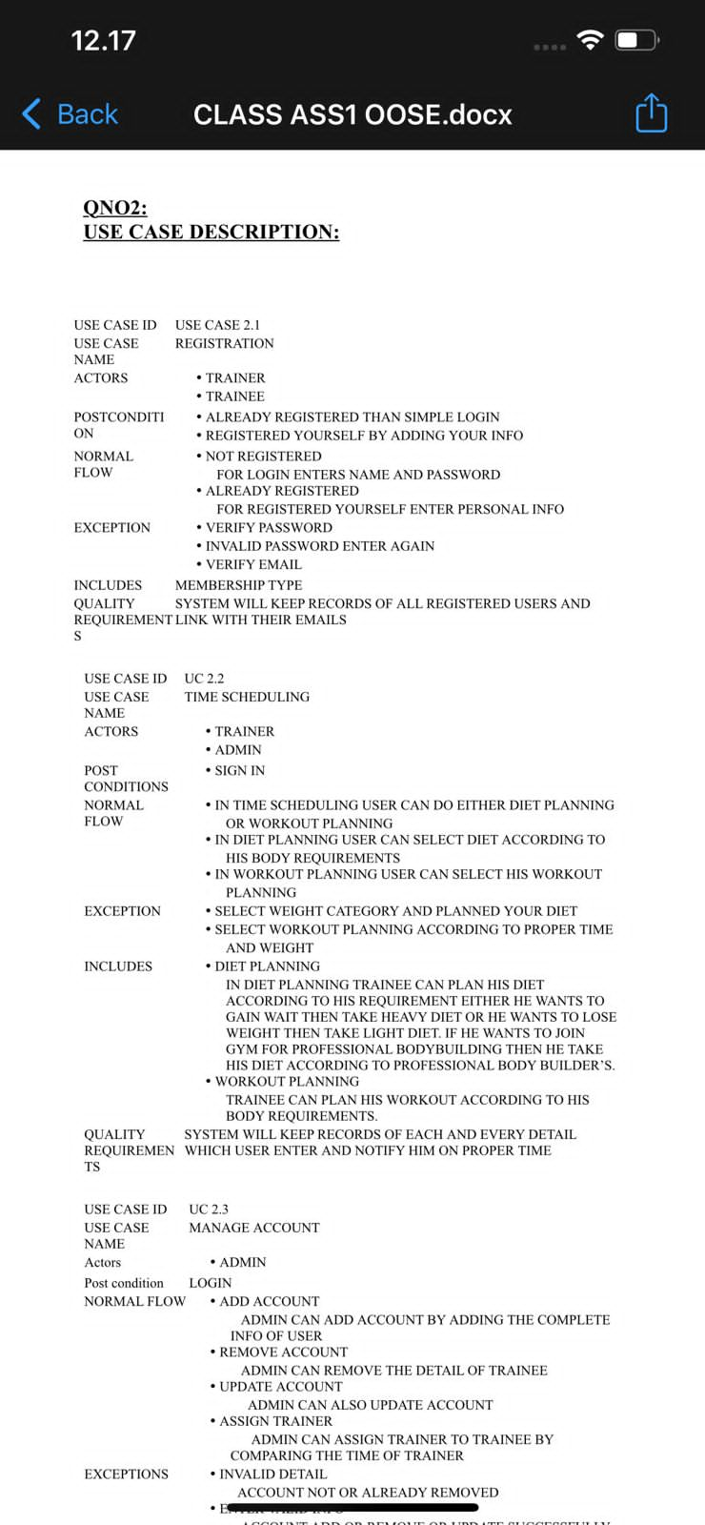

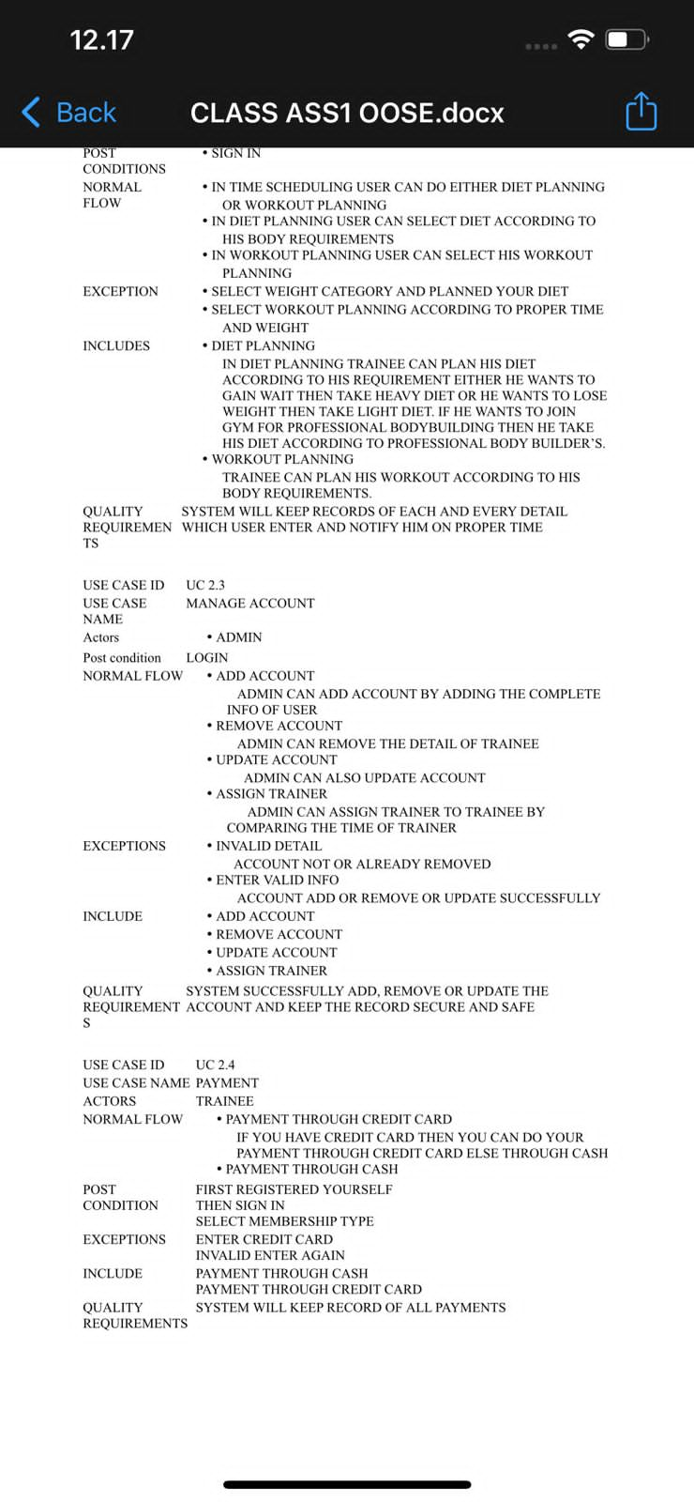

ACTIVITY DIAGRAM:

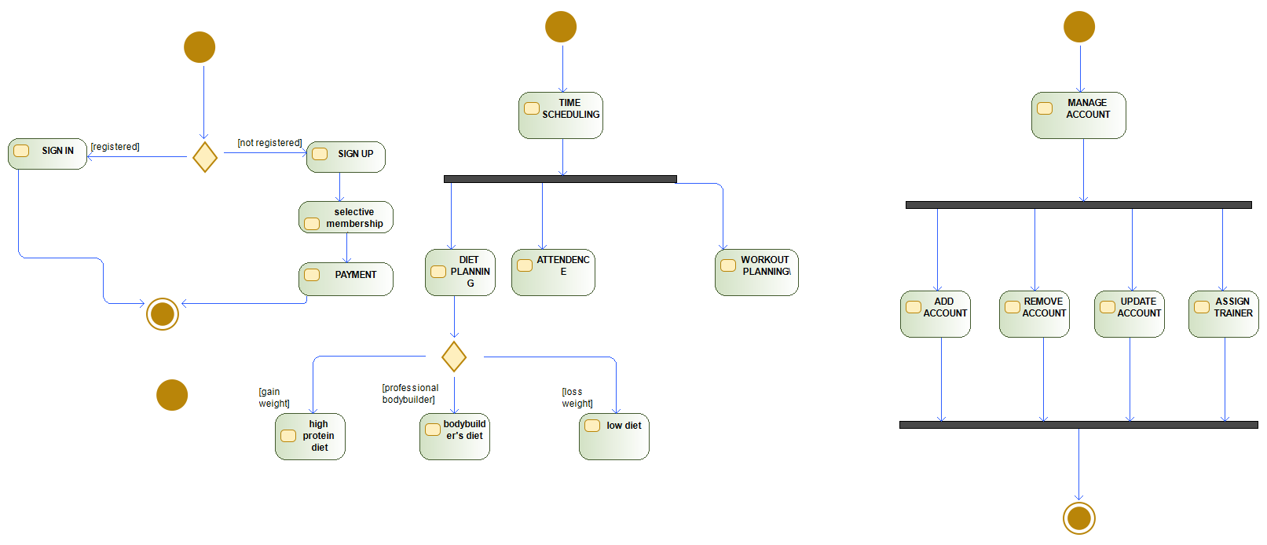

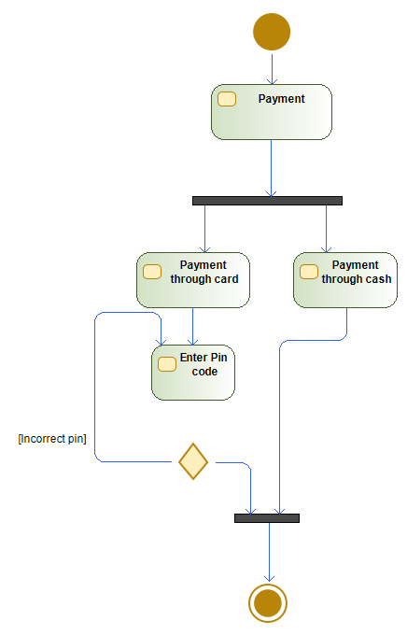

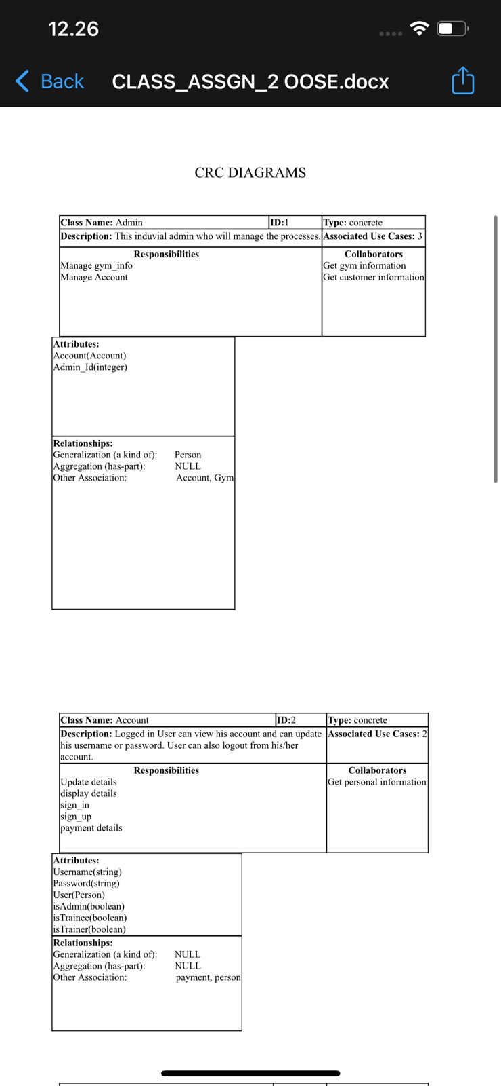

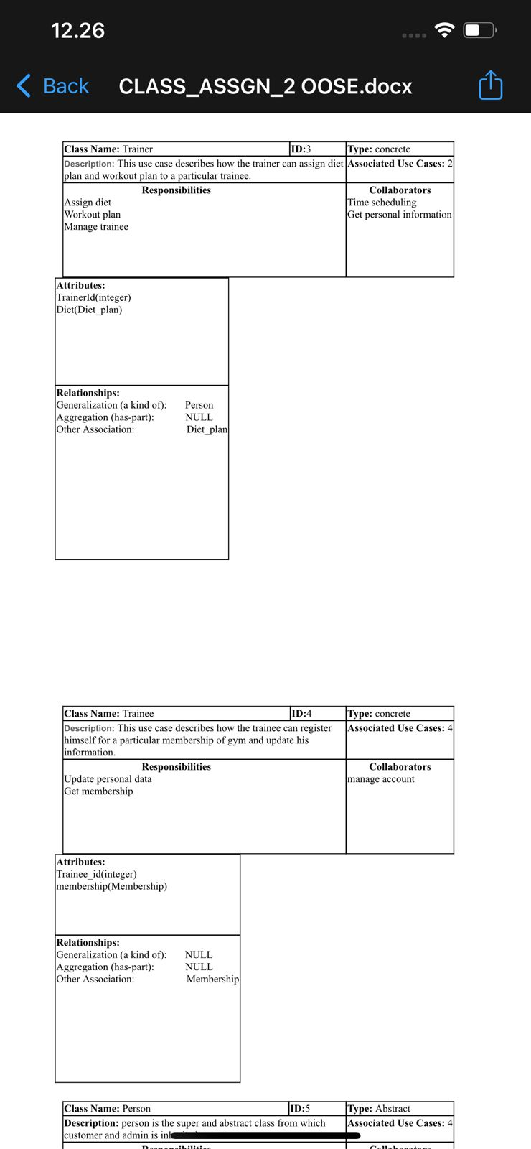

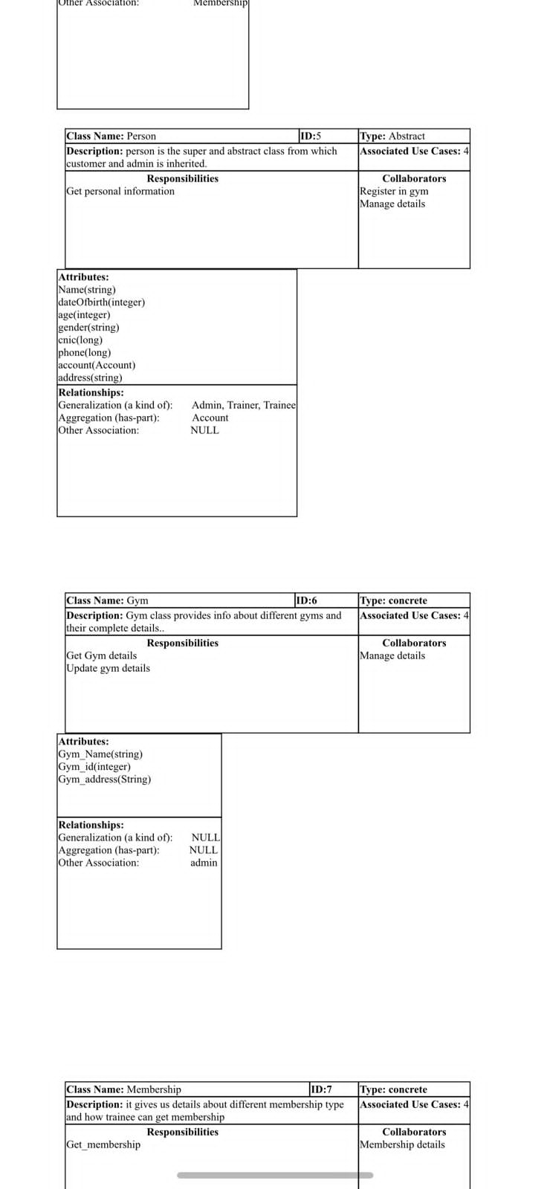

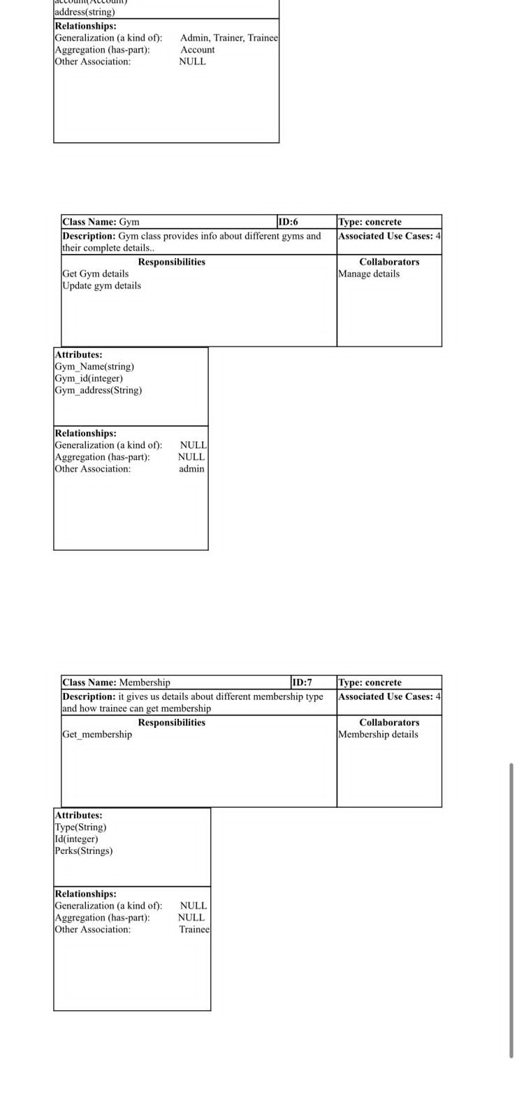

CLASS DIAGRAM:

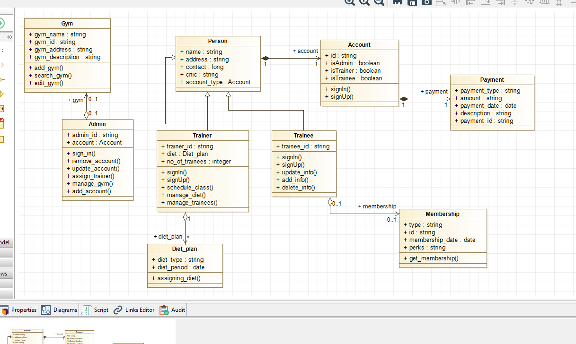

OBJECT DIAGRAM:

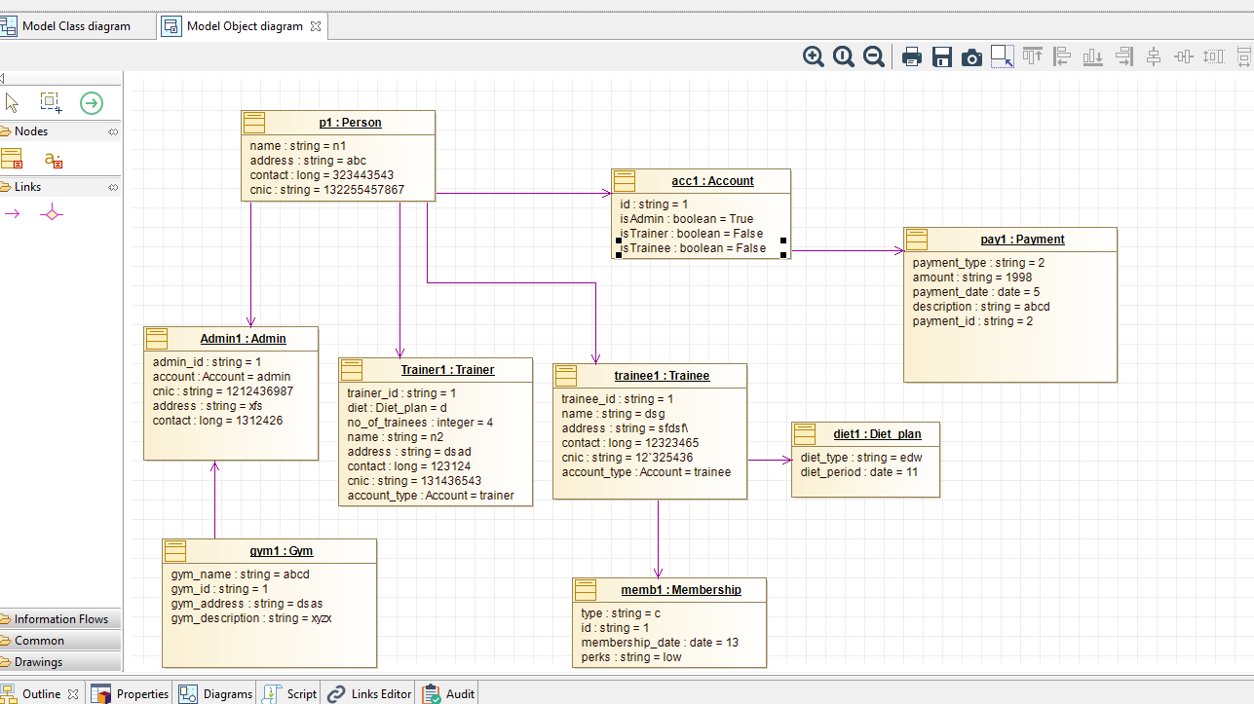

SEQUENCE DIAGRAM OF TRAINEE:

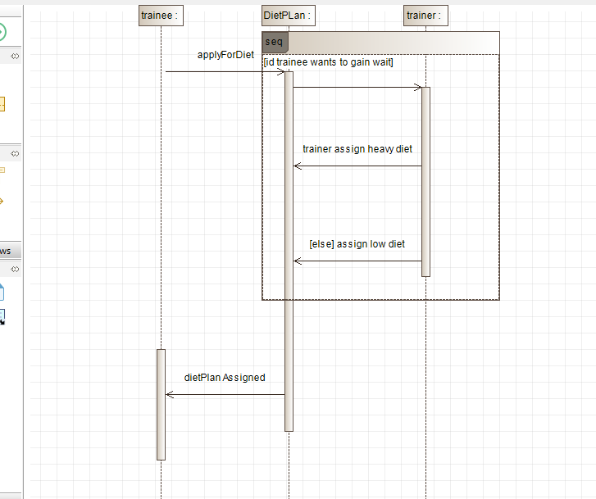

SEQUENCE DIAGRAM OF ACCOUNT MANAGEMENT:

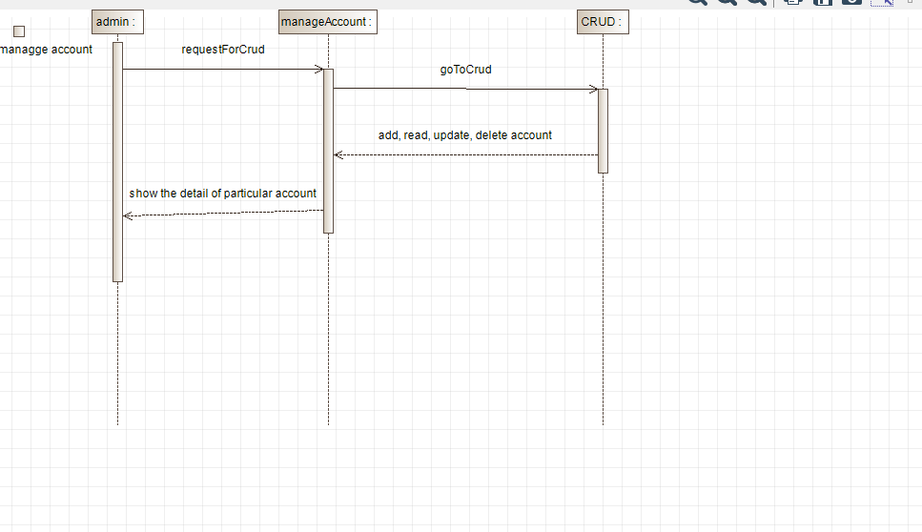

SEQUENCE DIAGRAM FOR PAYMENT:

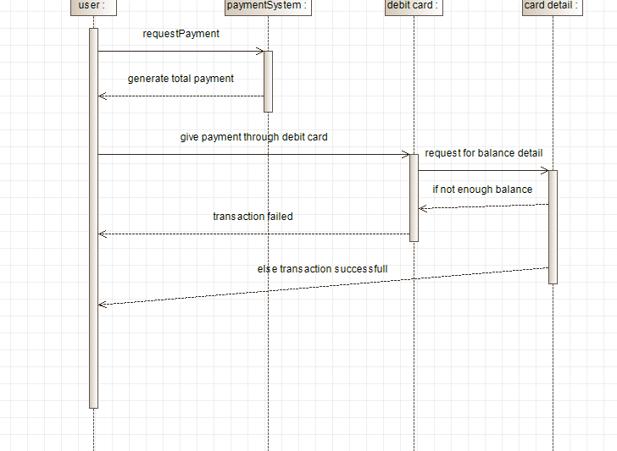

**DEPLOYEMENT DIAGRAM:**

